Article ID: 1095
Article Name: My Washing Machine is moving and shaking when on the spin cycle
Topic Location: Laundry Washer Dryer Machine Moving / Vibration
Meta-data: moving noisy shakes moves/unbalanced vibrates spinning
Related Articles:
Related Questions:
PNC
DIY
Safety
Link
Email
Book Engineer
Multimedia
Brand
Article Content:
Make sure the transit bolts have been removed from the rear of the appliance.
These are in place during transportation to make sure that no damage occurs to the drum in the machine.
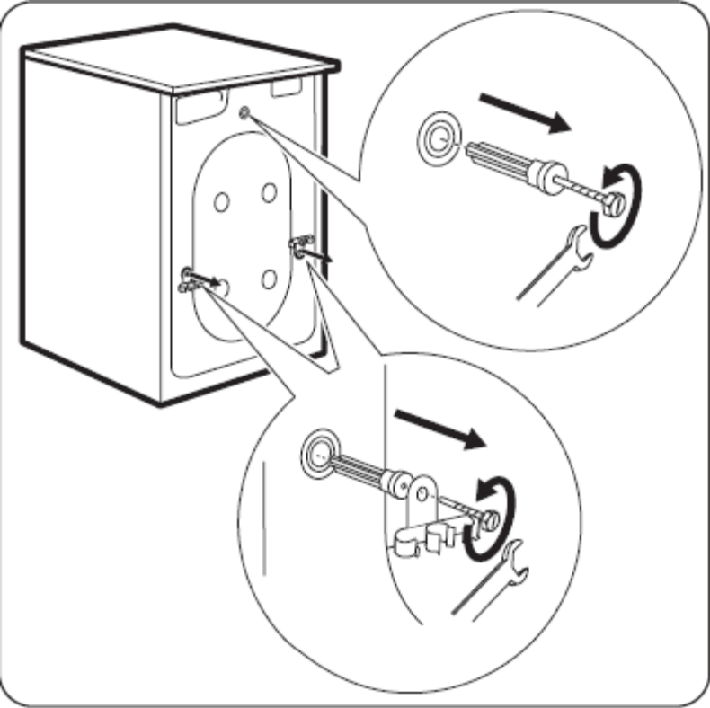
Level the appliance by raising or lowering the feet. The appliance must be stable on a hard flat floor. If necessary, use a spirit level. Any adjustment can be made with a spanner

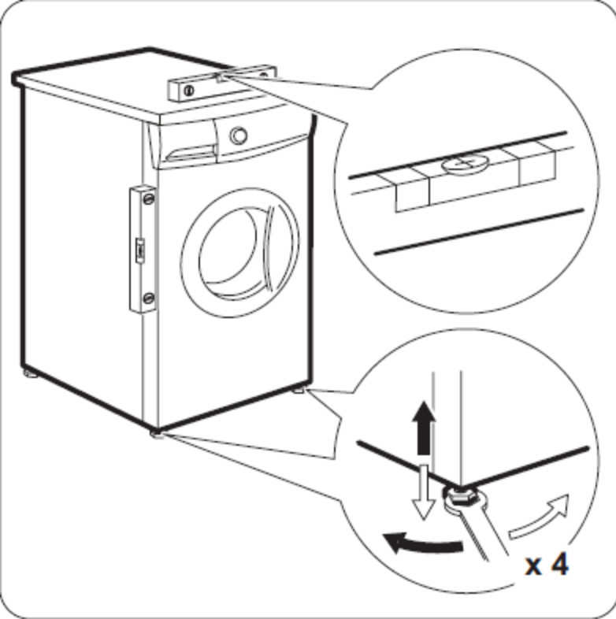

Accurate levelling prevents vibration, noise and displacement of the appliance during operation, especially fast spin cycles.
Repeat the levelling checks at regular intervals in case the feet or flooring have become unbalanced.

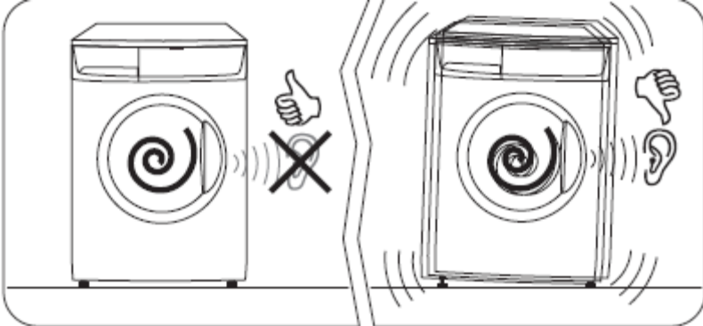

Make sure all hoses are securely fitted and clipped to the rear of the casing of the appliance

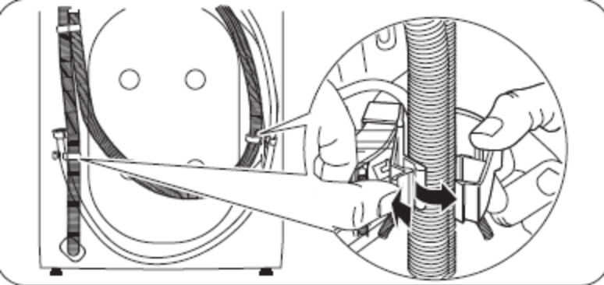

Loose fitting hoses can vibrate against the appliance during spin cycles and create a ‘knocking’ noise.

Check that the washing has been loaded correctly and make sure no fabrics are caught between the door and drum.

REMEMBER! One item loaded can cause an unbalanced spin the same as an overloaded drum could.

